Inheritance in python
When a class derives from another class. The child class will inherit all the public and protected properties and methods from the parent class. In addition, it can have its own properties and methods,this is called as inheritance.
Python Inheritance Syntax
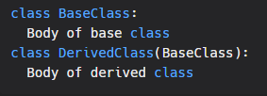
Derived class inherits features from the base class where new features can be added to it. This results in re-usability of code.
Types of inheritance:
- Single inheritance
- Multiple inheritance
- Multilevel inheritance
- Hierarchical Inheritance
- Hybrid Inheritance
We will see the explaination and example of each type of inheritance in the later tutorials
Single Inheritance:
Single inheritance enables a derived class to inherit properties from a single parent class, thus enabling code reusability and the addition of new features to existing code.
Example:
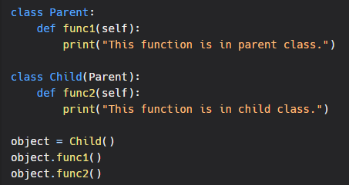
Output:
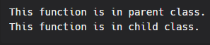
Multiple Inheritance:
When a class can be derived from more than one base class this type of inheritance is called multiple inheritances. In multiple inheritances, all the features of the base classes are inherited into the derived class.
Example:
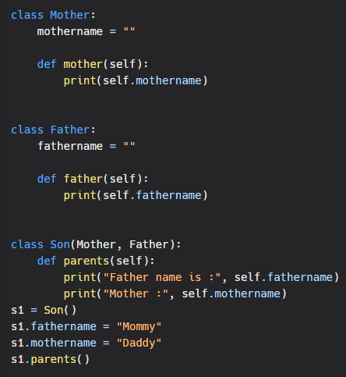
Output:
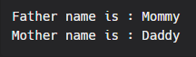

Multilevel Inheritance :
In multilevel inheritance, features of the base class and the derived class are further inherited into the new derived class. This is similar to a relationship representing a child and a grandfather.
Example:
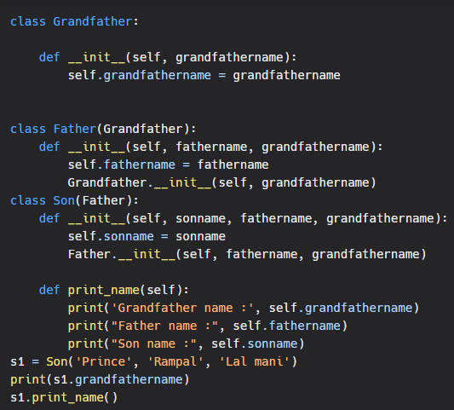
Output:
George
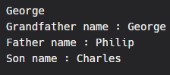

Hierarchical Inheritance:
When more than one derived class are created from a single base this type of inheritance is called hierarchical inheritance. In this program, we have a parent (base) class and two child (derived) classes.
Example:
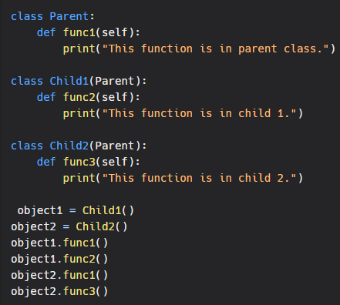
Output:
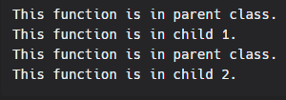

Hybrid Inheritance:
Inheritance consisting of multiple types of inheritance is called hybrid inheritance.
Example
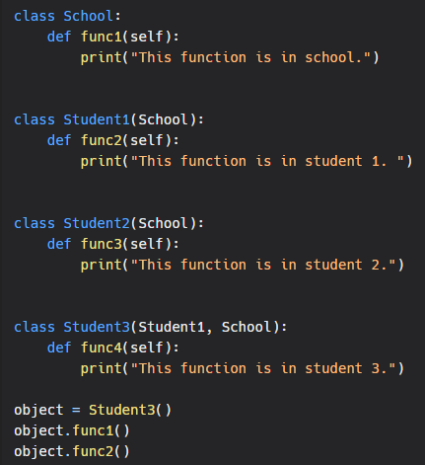
Output:
